Dorthea Tanning’s art piece *Untitled* done with etching, sugar-lift aquatint, aquatint, and soft-ground etching depicts what appears to be a Black man and a white woman intertwined. The significance of this intertwining is that this art piece was created in 1970 when America was still enduring a time of intense racial tension and discrimination against African Americans. In the etching, it appears that the two bodies are partaking in sexual activity, which was seen as taboo, as mentioned in Nell Irvin Painter’s novel *The History of White People.* Painter discusses the concept of racial mixing and race purity, which goes against what is presented in Tanning’s art piece.[1]

The background of Tanning’s piece appears to be a nature-y-outdoorsy-doomsday like setting. Everything is done in black and white, and there seems to be large rock-like structures surrounding the couple. The message that one may receive from her piece is that love can endure any hardship, and that true love is worth rebelling against societal norms and expectations. The intensity of the intertwining bodies showcases just how deep their love for one another goes; it appears soul deep. In the etching, it is difficult to discern which elements belong to her body as opposed to his. There also seems to be an insect of some kind in the top left corner that seems to be watching the couple and judging their actions. Perhaps the insect is supposed to represent society and is silently damning the couple, while also making plans to separate them from one another before a spawn is produced in order to maintain racial purity.

Another theme Tanning’s piece fights against that is also present in another book we discussed in class, Henry Louis Gates’s *Stony the Road,* is white supremacy and pushing the white agenda. The art piece is clashing with the antiquated ideals of American society, wherein Blacks are considered an inferior race and unworthy of being associated with the white race. Tanning utilizes her etching to illustrate that not all white people of the time harbored anger or fear toward Black people, specifically Black men. Tanning encapsulates the idea that love is race-blind and is simply an emotion meant to be felt in the purest of forms regardless of public consciousness.[2]

Tanning’s etching is important because it symbolizes the evolving nature and beliefs of American society. Now, seeing interracial couples and their children is the norm, which would have given racist Americans of the 70s a heart attack. Her piece may enhance one’s thoughts on race or racism because she showcases a Black man and a white woman unifying themselves despite what people at the time, and even some people today, deemed as wrong and blasphemous. The love that the two etched people have for one another is what most people desire to have, and their love shouldn’t be shamed or dismissed because of the levels of melanin present in their skin.

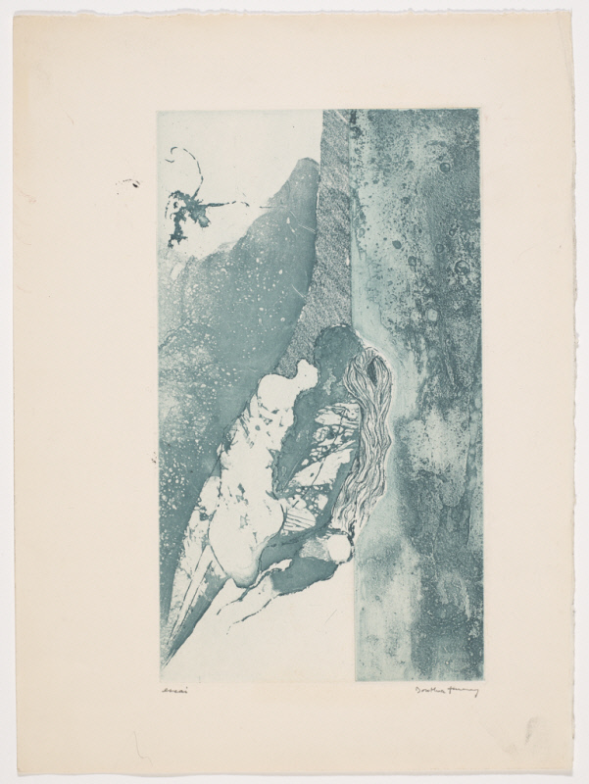

1. Painter, Nell Irvin. *The History of White People.* New York: W. W. Norton, 2011.
2. Gates Jr., Henry Louis. *Stony the Road*. New York: Penguin Press, 2019.