Bright Places and Infinite Capacities

Alexandria White

Word count: 1,330

Publications: CNN Entertainment, Buzzfeed, The New York Times

Description: This is an article discussing the possible effects of movies, specifically, *All the Bright Places,* depicting suicide, grief, and mental illness on high school-aged individuals.



“All the Bright Places.” Credit: Netflix

**Introduction/Background**

*All the Bright Places* is a Netflix movie directed by Brett Haley based upon the young-adult novel of the same name by Jennifer Niven. The story focuses on the relationship between Theodore Finch (Justice Smith) and Violet Markey (Elle Fanning) and how they endure the struggles of high school while battling family and mental health issues. In the film adaptation, the opening scene shows the characters’ life-altering encounter when Violet stands on the railing of a bridge preparing to jump, and Theodore comes onto the scene during his run. The audience quickly learns that the bridge is where Violet’s sister, Eleanor, was killed in a car accident the year before. The grief surrounding Violet on the day she met Theodore, was caused in part because of the location, but also the date which happened to be her sister’s birthday. To distract Violet from jumping, Theodore climbed on the railing, lifted one foot, and pretended he was going to jump, causing her to realize the gravity of her actions. Once Theodore coaxed her down, they went their separate ways, only to see each other in class the following day. They were assigned a project to visit a wonder of Indiana and do a presentation; Theodore convinced Violet to be his partner, and they embarked on their journey to fulfill the assignment (*All the Bright Places,* 2020).Elle Fanning and Justice Smith in “All the Bright Places.” Credit: Michele K. Short/Netflix

Throughout the movie, Violet’s almost suicide attempt because of her grief is only mentioned like twice, and the audience is let in on the fact that something is not quite right with Theodore- possibly an undiagnosed mental disorder. He disappears for days and weeks at a time, he has mandated appointments with the school counselor, and he is coping with a lot of family drama. His father abused and abandoned him, his mother is never home, and his sister is responsible for taking care of him. Theodore also endures a lot of issues at school, like being called a “freak,” and fighting. However, the movie focuses more attention on the dynamic between Theodore and Violet, their budding romance, and the wonders they visit to help Violet find herself and cope with her loss. There are glimpses of Theodore’s internalized struggle, and the questions he asks, and comments made in passing should invoke worry but are instead viewed as quirks. On one of their stops, they visited a “Before I Die… wall,” where Theodore wrote that before he dies, he wishes to “stay awake,” and Violet wrote to “be brave” (*All the Bright Places,* 2020). The movie carries on, and the meaning behind Theodore’s response becomes clear; he was looking for a reason to not only “stay awake,” but to stay alive. He kept a running list of possible reasons on his bedroom walls on sticky notes, but unfortunately, in the end, he was unable to see his life at “full brightness” (*All the Bright Places,* 2020).

*All the Bright Places,* the film, handled the conversation surrounding mental health and suicide much differently than other media texts on Netflix’s platform. To avoid the possible behavioral effects (actions triggered by media) of the movie, there were extensive measures taken (Potter, 2016). In addition to seeking the guidance of mental health scientists and creating a website for viewers to go to for resources, the producers intentionally left out the more graphic elements of Theodore’s death, as well as conversations surrounding his previous attempt on his life as depicted in the novel (Miller, Rosen, and Keegan, 2020). There was a foreshadowing of what would become of Theodore in various scenes- the first when he held his breath in the bathtub, and the second when they visited the “bottomless lake” for one of the wonders, and he did the same. Theodore’s suicide shook the whole town; his sister, support group, school counselor, and Violet all mourned his death. The signs of his impending actions were not clear to those dearest to him, and the emotional effects (triggering emotions leading to desensitization) were apparent (Potter, 2016) and (Parekh, 2018). Violet, especially, was devastated that she was unable to save Theodore from himself (*All the Bright Places,* 2020).

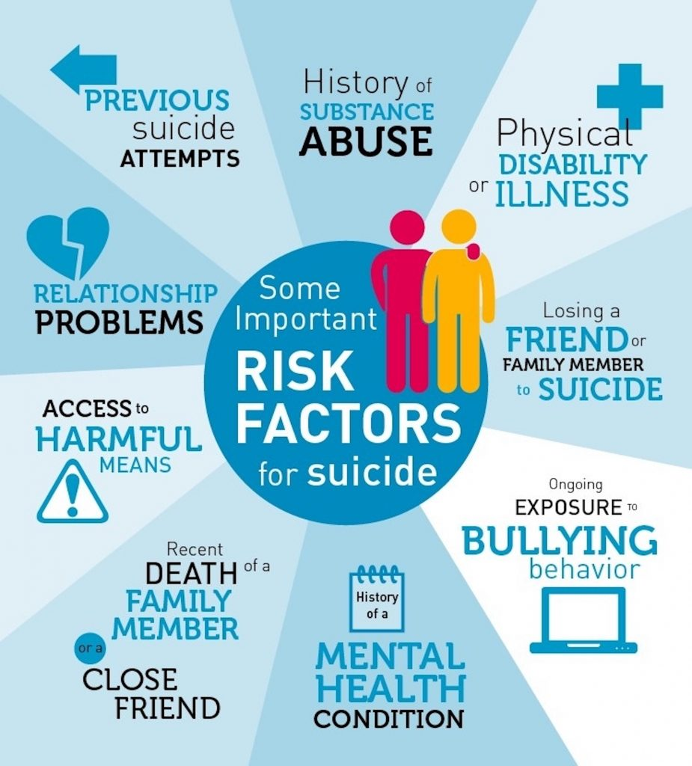“Suicide Risk Factors.” Credit: South Carolina Youth Suicide Prevention Initiative

**Course-related Concepts and Themes/PSA**

The warning signs of suicide are not always glaringly obvious. Sometimes parents, guardians, and friends need to take a second look (Potter, 2016). In the case of Theodore, people ignored his underlying cry for help and only focused on what they could understand. They understood the labels they placed on him like “freak,” and the belief effects (faith that something is real) of society indicate that once someone is given a derogatory label, they are viewed as inferior (Potter, 2016). Theodore’s eventual suicide by drowning has the potential to cause a negative valence on audiences, particularly on those of high school-age or dealing with mental illness (Potter, 2016). *All the Bright Places* has the potential short and long-term effects of motivating others to take their own lives or encouraging them to seek help. Statistics indicate that high exposure to media texts about suicide causes the rates of an attempt by individuals to increase (Bridge et al., 2019).

At the end of the day, media texts are constructed, and the goals of mass media industries are to make money (Potter, 2016). Audiences that view films with plot lines similar to *All the Bright Places* have identical media effects. Often, critics of these texts use deduction (general principles to explain particulars) to examine the impact on impressionable viewers, particularly in the 14-18 bracket (Potter, 2016). One thing this film avoided doing was glorifying suicide, grief, and mental health disorders. Instead, they portrayed the message of understanding the deeper meanings associated with people’s actions and relying on a network of individuals to heal from one’s pain (Parekh, 2018). The dimensions of reality (actuality of occurrence, the possibility of occurrence, social utility judgment, identity judgment) are prevalent in this text and set the stage for open dialogue with trusted individuals and licensed professionals surrounding these issues (Potter, 2016).

High school students, it is essential to open up to those you trust about how you may feel mentally, emotionally, and physically. Likewise, if you feel that you want to pursue alternative communication options, there are resources available. You can speak with someone confidential, who will listen to you, and refer you to the proper professional (Kee, 2018). Your emotions are valid, and no matter how low you feel, or the amount of pain you have endured, there is hope. The situation can get better. If you or anyone you know is suffering or needs someone to talk to call the suicide hotline: 1-800-273-8255 or text the crisis line: (741-741). Please reach out for help if you need it; no one has to go through their pain alone.

[](https://www.youtube.com/embed/mu4AbTGTDBw?feature=oembed)

"All the Bright Places” cast discussing mental health on YouTube. Credit: Netflix

**References**

All the Bright Places: Netflix. (2020, January 29). Retrieved from <https://www.allthebrightplacesfilm.info/#gallery>

Bridge, J. A., Greenhouse, J. B., Ruch, D., Stevens, J., Ackerman, J., Sheftall, A. H., … Campo, J. V. (2019, April 28). Association Between the Release of Netflix's 13 Reasons Why and Suicide Rates in the United States: An Interrupted Time Series Analysis. Retrieved from <https://www.sciencedirect.com/science/article/abs/pii/S0890856719302886>

Kee, C. (2018, September 25). Here's What Happens When You Call Into A Suicide Prevention Hotline. Retrieved from <https://www.buzzfeednews.com/article/carolinekee/what-happens-when-you-call-suicide-hotline>

Miller, J., Rosen, C., & Keegan, R. (2020, February 28). How Netflix's All the Bright Places Tackled Teen Suicide in the Wake of 13 Reasons Why. Retrieved from <https://www.vanityfair.com/hollywood/2020/02/all-the-bright-places-movie>

Parekh, R. (2018, June). Suicide Prevention. Retrieved from <https://www.psychiatry.org/patients-families/suicide-prevention>

Potter, W. J. (2016). *Media literacy*. Los Angeles: SAGE.